WEEK 10: ENERGY
***

Part 1: Social Interaction (3’)
Let’s talk about your electricity consumption:
1. What are some appliances in your household that consume much electricity?
.In my house There are some essential electronic appliances consume a lot of eletricity energy like ater heater to provide warm water in winter or fridge to keep food longer. Especially, my house has some CNC machines for my dad work as a carpenter andit use a lot of electricity to carve wood
2. How do you manage your daily electricity usage in your home?
. To manage my daily usage of electricity, I always turn off the light or any electronic device when I don't have to use it. It works pretty good that my house electricity bill have decrease notablely.
3. Are you actively involved in any renewable energy programs?
No, I have’nt but I have seen some news on TV about renewable energy programs and I think it’s very interesting, potential and promissing to solve the energy crisis so in the future I hope I can involve in those program
Let’s talk about recycling:
1. Do you prefer recycling or throwing things away?
Yes, I like to recycling thing. I think it is important to recycling those items no longer in use, it can help me to save more money and reduce waste
2. What items do you usually recycle at home, like paper, plastic, or glass?
personally, I have learned to recycle new paper from old book or bottle from DIY programs on TV. And thanks to its, I don't have to buy new notebook anymore.
3. Are there any recycling programs and collection schedules in your area?
I live in my school dormitory, and we have a collection schedule. Everyday, at 7Am or 6PM there are some collector who harvest waste and classify them into recyclable and non-recylcable
Part 2: Solution Discussion (4’)
Situation: You're determined to reduce your energy consumption and make a positive impact on the environment. Here are three options you're considering: investing in energy-saving appliances, unplugging devices when you’re not using them, or reducing the need for artificial lighting. Which one do you think is the best option you will do first? What are the reasons for your choice?
Unplugging devices when not using is... there are some following reason for my opinion.
First, there a lot of device we plug in all day, and it use a lot of electricity. Some device that don't have a auto mechanism to cut off the electricity when not use, so we need to unplug in whenever we don't use. For example, the water heater in bathroom, many house .....
Considering others option, I think reducing the need for artificial lighting is not realistic. becau.....
And the investment in energy-saving is actrully promissing, but it will take long time to see the efficent, and might cost a lot of money.
So in conclusion...

Part 3: Topic Development (5’)

Topic: Effective ways to save natural resources

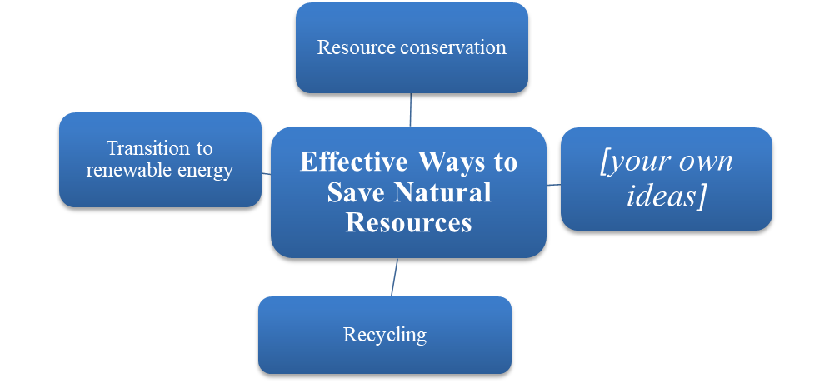

Follow-up questions:
1. Can you discuss the concept of "reduce, reuse, and recycle"?
2. How does our energy consumption affect future generations and the planet?
natural resources crisis is a tough challenge for present day human. Some resource such as coal, oil and gas are consumed rappidly year by year, and will be run out of in 50-100 years. From my viewpoint, I offer some effective ways to save the natural resources.
The most important is we need to take action on resource conservation as soon as possible. goverment must have some ser to reducce the consumption of resource in many field like logistic or manufacturing. Citizen can take some realistic action to manage daily electricty use like unplug, and reduce of purchasing those one-used item.
Some modern way we can considering like transition to renewable energy. We can change our vehicle to some e-car, e-bike like vinfast or tesla. Some enviromentally friendly resource like biogas which pproduce from biomass, agricultural wastes can a subtitute energy for natural gas. use in cooking. ... Use a solar, wind energy which is a nearly unlimited ênrgy
Recycling is of paramount importance in saving resource program. Government need to invest more in recycling residential waste, a more effective solution than landfill. For citizen, we can take more classes about how to individually recycle things home like paper or wood. Or we can collect recyclable items and give them to trustable establishment.
In conlusion, government and citizen can take conserve energy, transite to renewable energy, recycling and propaganda as a potential measure to save natural resources.

